EXP 08 : Comparation of Analog, Digital and Hybrid Beamforming
AIM :
To design and compare Analog, Digital, and Hybrid Beamforming using MATLAB by generating and analyzing the array factor of each method, and to study how each beamforming technique steers the radiation pattern toward a desired direction.
THEORY :
Beamforming is a signal-processing technique used in antenna arrays to direct signals toward a chosen angle by adjusting phase and amplitude across elements. Modern wireless systems (4G/5G/6G) use three main beamforming architectures:

1. Analog Beamforming
- Implemented in the RF domain using phase shifters.
- Only one RF chain for all antennas.
- Steers one beam at a time.
- Low hardware cost and power consumption.
Weight expression:
$$w_{n}=e^{-j2π\frac{d}{λ}nsin⁡θ_{0}}$$

2. Digital Beamforming
- Each antenna has its own RF chain & ADC/DAC.
- Beamforming is done in the digital baseband.
- Supports multiple beams and multi-user MIMO.
Array Factor:
$$AF(θ)=∣\sum_{n=0}^{N-1}{w_{n}}e^{j2π\frac{d}{λ}nsin⁡θ}∣$$​n=0∑N−1​wn​ej2πλd​nsinθ

3. Hybrid Beamforming
- Combination of analog and digital beamforming.
- Uses a few RF chains + phase shifters.
- Provides a good balance between performance and cost.
- Used in 5G mmWave systems.
Weights:
$$w=W_{RF}⋅W_{BB}$$
PROCEDURE :
- Define antenna array parameters: number of elements, spacing, wavelength.
- Select desired steering angle (e.g., 20°).
- Analog Beamforming:
- Generate phase-shift weights for all antennas.
- Compute array factor.
- Digital Beamforming:
- Apply complex baseband weights.
- Compute array factor for digital steering.
- Hybrid Beamforming:
- Create analog precoder using phase-only control.
- Apply digital baseband weight combining.
- Compute array factor.
- Plot all beam patterns (Analog, Digital, Hybrid) on the same graph.
- Compare beamwidth, peak direction, and pattern sharpness.
PROGRAM :
% Analog, Digital, Hybrid Beamforming Comparison
clear; clc; close all;

N = 16;
d = 0.5;
lambda = 1;
theta = -90:0.1:90;
th = deg2rad(theta);

% Desired steering angle
theta0 = 20;
th0 = deg2rad(theta0);

% ---- Analog Beamforming ----
w_analog = exp(1j*2*pi*(d/lambda)*(0:N-1)'*sin(th0));
w_analog = w_analog./N;

AFa = zeros(size(th));
for i = 1:length(th)
AFa(i) = abs(sum(w_analog.'.*exp(1j*2*pi*(d/lambda)*(0:N-1)*sin(th(i)))));
end
AFa = AFa/max(AFa);

% ---- Digital Beamforming ----
w_dig = exp(1j*2*pi*(d/lambda)*(0:N-1)'*sin(th0));
w_dig = w_dig/sum(abs(w_dig));

AFd = zeros(size(th));
for i = 1:length(th)
AFd(i) = abs(sum(w_dig.'.*exp(1j*2*pi*(d/lambda)*(0:N-1)*sin(th(i)))));
end
AFd = AFd/max(AFd);

% ---- Hybrid Beamforming ----
N_RF = 4;
W_RF = exp(1j*2*pi*(d/lambda)*(0:N-1)'*sin(th0));
W_RF = W_RF./abs(W_RF);

W_BB = ones(N_RF,1)/N_RF;
w_hybrid = W_RF .* kron(W_BB, ones(N/N_RF,1));

AFh = zeros(size(th));
for i = 1:length(th)
AFh(i) = abs(sum(w_hybrid.'.*exp(1j*2*pi*(d/lambda)*(0:N-1)*sin(th(i)))));
end
AFh = AFh/max(AFh);

% ---- Plot ----
plot(theta,AFa,'LineWidth',2); hold on;
plot(theta,AFd,'LineWidth',2);
plot(theta,AFh,'LineWidth',2);
xlabel('Angle (deg)'); ylabel('Normalized AF');
title('Analog vs Digital vs Hybrid Beamforming');
legend('Analog','Digital','Hybrid'); grid on;

OUTPUT :
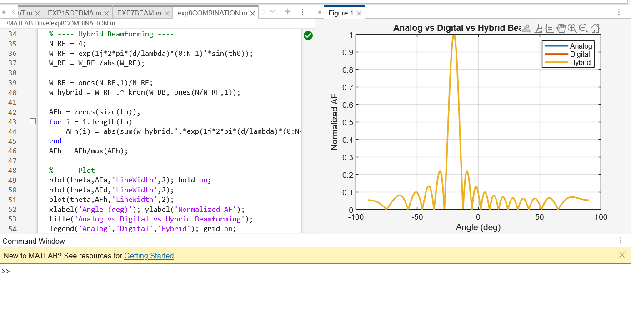

CONCLUSION :
The comparison reveals that digital beamforming offers the best performance and flexibility but at the highest hardware cost due to many RF chains. Analog beamforming is low-cost and energy-efficient but limited to single-beam operation. Hybrid beamforming provides a compromise by reducing RF chain count while still achieving improved steering accuracy. Thus, hybrid beamforming is widely adopted in modern 5G mmWave systems for efficient high-frequency communication.

